BOLGATANGABASKETS.COM PRICE-LIST
BASKET TYPES |  | Size | Price ($) | 15% | 25% | 30% |  | 40%
Round Market baskets | 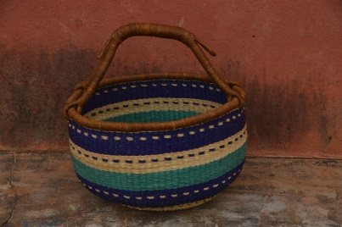 | Small 25x 15cm | 10 | 8 | 7.5 | 7 |  | 6
 |  | Medium 30x 15cm | 15 | 12 | 11.25 | 10.5 |  | 9
 |  | Large 35x 25cm | 20 | 16 | 15 | 14 |  | 12
U-shopper | 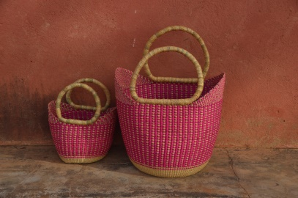 | Small 20 x 15 cm | 12 | 9.6 | 9 | 8.4 |  | 7.2
 |  | Medium 30 x 20 cm | 15 | 12 | 11.25 | 10.5 |  | 9
 |  | Large 40 x 30 cm | 20 | 16 | 15 | 14 |  | 12
Pot basket | 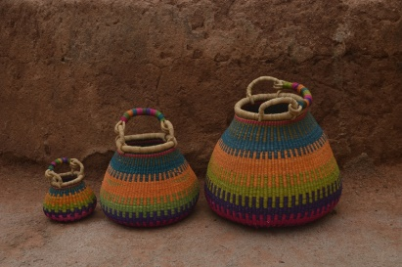 | Small 20 x 15 cm | 12 | 9.6 | 9 | 8.4 |  | 7.2
 |  | Medium 25 x 20 cm | 18 | 14.4 | 13.5 | 12.6 |  | 10.8
 |  | Large 30 x 30 cm | 22 | 17.6 | 16.5 | 15.4 |  | 13.2
Oval basket | 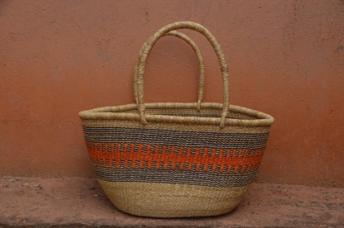 | 45 x 30 x 30 cm | 20 | 16 | 15 | 14 |  |  | 12
Baby Moses Basket | 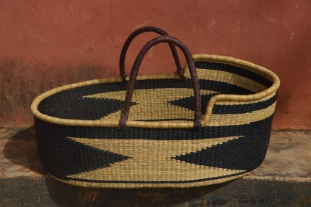 | 75 x 42 x 23 cm | 50 | 40 | 37.5 | 35 | 30
Changing baskets | 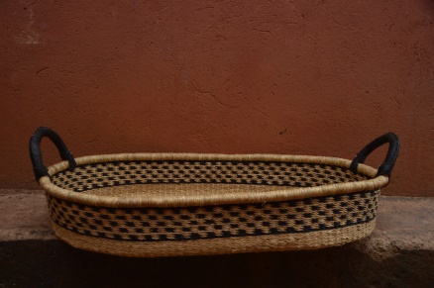 | 75 x 42 x 13 cm | 30 | 24 | 22.5 | 21 | 18
Doll Moses Basket | 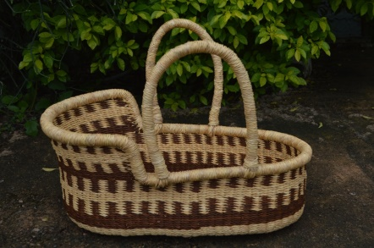 | 50 x 20 x 15 cm | 20 | 16 | 15 | 14 | 12
Bolga fans | 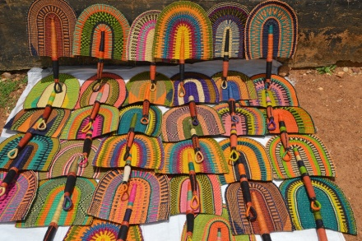 | 45 x 25 cm | 10 | 8 | 7.5 | 7 | 6
Laundry baskets | 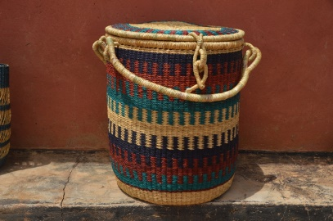 | 60 x 35 x 35 cm | 40 | 32 | 30 | 28 | 24
Mini me baskets | 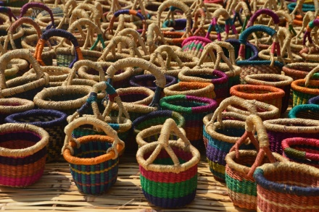 | 10 x 8 x 8 cm | 4 | 3.2 | 3 | 2.8 | 2.4
Pot bags | 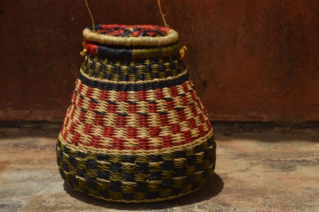 |  | 15 | 12 | 11.25 | 10.5 | 9
Binta’s bag | 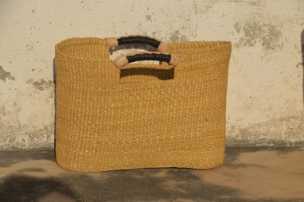 | 40 x 25 cm | 15 | 12 | 11.25 | 10.5 | 9
Place mats | 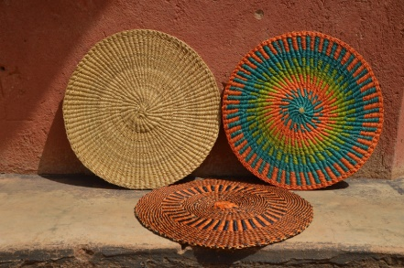 | Set of 6 | 20 | 16 | 15 | 14 | 12
Dog basket | 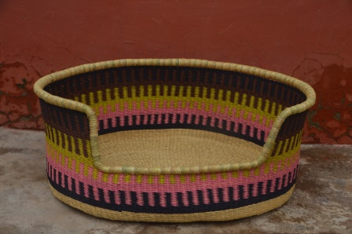 | 70 x 45 x 30 cm | 45 | 36 | 33.75 | 31.5 | 27
Cat pod | 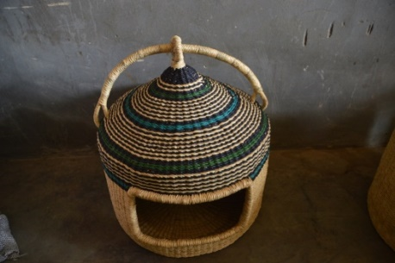 |  | 40 | 32 | 30 | 28 | 24
Bolga hats | 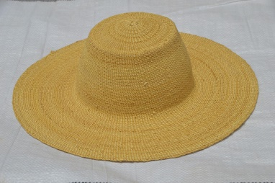 |  | 10 | 8 | 7.5 | 7 | 6
Big Bottle Baskets | 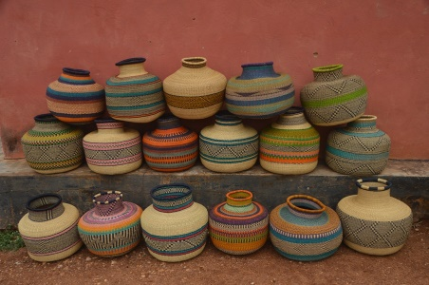 | 40 x 40 x 20 cm | 50 | 40 | 37.5 | 35 | 30
Picnic baskets | 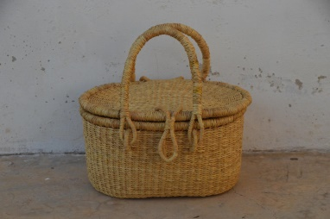 | 30 x 20 x 15 cm | 20 | 16 | 15 | 14 | 12
Lady’s bag | 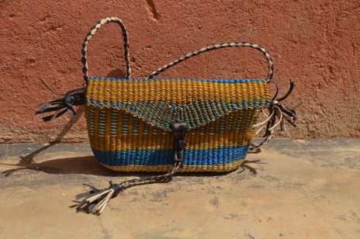 | 25 x 15 cm | 15 | 12 | 11.25 | 10.5 | 9
Large tote | 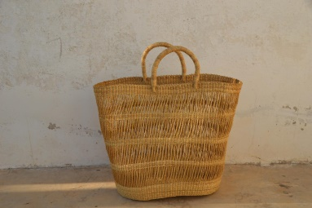 | 45 x 40 x 25 cm | 20 | 16 | 15 | 14 | 12

